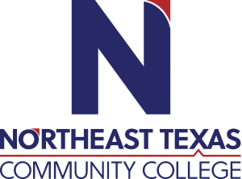 | Math 2413.033 Calculus I  Course Syllabus: Spring 2026
“Northeast Texas Community College exists to provide responsible, exemplary learning opportunities.”

Tonya McCleskey, Professor of Mathematics
Office: Online by appointment only
Phone: 936-463-8473
Email: tmccleskey@ntcc.edu

Office Hours | Monday | Tuesday | Wednesday | Thursday | Friday | Online
Office Hours | Online by appointment only | Online by appointment only | Online by appointment only | Online by appointment only | Online by appointment only | Everyday via TEAMs Messaging & Email

The information contained in this syllabus is subject to change without notice. Students are expected to be aware of any additional course policies presented by the instructor during the course.

Catalog Course Description: Limits and continuity; the Fundamental Theorem of Calculus; definition of the derivative of a function and techniques of differentiation; applications of the derivative to maximizing or minimizing a function; the chain rule, mean value theorem, and rate of change problems; curve sketching; definite and indefinite integration of algebraic, trigonometric, and transcendental functions, with an application to calculation of areas.

Prerequisite: MATH 2412 (Precalculus) or its equivalent.

Student Learning Outcomes:

2413.1 Develop solutions for tangent and area problems using the concepts of limits, derivatives, and integrals.

2413.2 Draw graphs of algebraic and transcendental functions considering limits, continuity, and differentiability at a point.

2413.3 Determine whether a function is continuous and/or differentiable at a point using limits.

2413.4 Use differentiation rules to differentiate algebraic and transcendental functions.

2413.5 Identify appropriate calculus concepts and techniques to provide mathematical models of real-world situations and determine solutions to applied problems.

2413.6 Evaluate definite integrals using the Fundamental Theorem of Calculus.

2413.7 Articulate the relationship between derivatives and integrals using the Fundamental Theorem of Calculus.

Core Curriculum Purpose and Objectives:

Through the core curriculum, students will gain a foundation of knowledge of human cultures and the physical and natural world; develop principles of personal and social responsibility for living in a diverse world; and advance intellectual and practical skills that are essential for all learning.

Courses in the foundation area of mathematics focus on quantitative literacy in logic, patterns, and relationships. In addition, these courses involve the understanding of key mathematical concepts and the application of appropriate quantitative tools to everyday experience.

Program Student Learning Outcomes:

Critical Thinking Skills

CT.1 Students will demonstrate the ability to 1) analyze complex issues, 2) synthesize information,

and 3) evaluate the logic, validity, and relevance of data.

Communication Skills

CS.1 Students will effectively develop, interpret and express ideas through written communication.

Empirical and Quantitative Skills

EQS.1 Students will manipulate numerical data or observable facts by organizing and converting

relevant information into mathematical or empirical form

EQS.2 Students will analyze numerical data or observable facts by processing information with correct

calculations, explicit notations, and appropriate technology.

EQS.3 Students will draw informed conclusions from numerical data or observable facts that are

accurate, complete, and relevant to the investigation.

Evaluation/Grading Policy:

A series of online homework (Lumen OHM) will be worth 30% of your final grade. Online chapter quizzes will be worth 10% of your overall grade. Midterm and Final Exams will contribute to 60% of the final grade (30% each).

Homework via Lumen OHM is graded when submitted.

OHM-Lumen Homework: 30%
Chapter Quizzes 10%
Midterm Exam: 30%
Final Exam: 30%
100% TOTAL

See breakdown of grades below:
100% - 90% = “A”
89% - 80% = “B”
79% - 70% = “C”
69% - 60% = “D”

Below 60% = “F”

Make-up exams will not be given unless the student has coordinated with the instructor prior to the exam.

Lumen OHM homework will require the use of “Late Passes” if not completed by the scheduled due date. Each student has 255 last passes that extend the assignment due date for 48 hours. Students may use more than one late pass per assignment that is past due. Any missed work will be made up at the discretion of the instructor. It is the student’s responsibility to contact the instructor.

Required Instructional Materials: Inclusive Access Course: A discounted textbook fee is added to your student account to cover the cost of the required access code. Inclusive Access Content: 978-1-938168-02-4. You have access to a free digital textbook on openstax.org. If you would like a printed textbook, these are available for purchase.

Publisher: Lumen ISBN: 978-1-938168-02-4

Other Course Requirements
The textbook is available for free in Blackboard as a PDF or digital version. Print copy is not required by highly recommended. A free online graphing calculator for Windows is available in Blackboard. Desmos is a free graphing utility available to students (Desmos.com).

Minimum Technology Requirements:
Graphing Calculator is required. TI-83/84 is preferred. A free online TI-83/84 will be available in Blackboard for PCs.

Below are some technical requirements for using Blackboard that will help your experience in this course.

You will see the NTCC Tech Support email address and phone number below. Please contact them if you run into any technical problems during the semester. Please let your instructor know you are having difficulties as well.

If you need further NTCC technical support services, please contact Austin Baker or Mary Lou Pemberton at:
abaker@ntcc.edu or 903-434-8279
mpemberton@ntcc.edu or 903-434-8270

Blackboard will work on both a Mac and a PC. (Chrome Books are known to have issues with Blackboard.) It is best to access Blackboard through Fire-Fox or Chrome as your web browser. If you have trouble with any of the activities working properly, you might change your web browser as your first solution. The Default Browser in Windows 10 is Edge. This browser does not do well with Blackboard! If you go to Windows Accessories you will find Internet Explorer still on your computer but is not your default browser. If you have any difficulties navigating with Edge, close it and go to Internet Explorer.

You can download Blackboard Student for your smart phone from the Play store or the App store.

More information is available for Technology Requirements and Support under the Student Resources – Technical Support Tab in Blackboard.

Required Computer Literacy Skills:
As an online student you will have a much different "classroom" experience than a traditional student. To ensure that you are fully prepared for your online courses, following is a list of expectations and requirements: Students in a hybrid and/or on-line program should be comfortable with and possess the following skill sets:
1. Self-discipline
2. Problem solving skills
3. Critical thinking skills
4. Enjoy communication in the written word

As part of your online experience, you can expect to utilize a variety of technology mediums as part of your curriculum:
1. Communicate via email including sending attachments
2. Navigate the World Wide Web using a Web browser such as Internet Explorer
3. Use office applications such as Microsoft Office (or similar) to create documents
4. Be willing to learn how to communicate using a discussion board and upload assignments to a classroom Web site
5. Be comfortable uploading and downloading saved files
6. Have easy access to the Internet
7. Navigate Blackboard, including using the email component within Blackboard. Instructions and tutorials for this are provided in your course.

For more information or technical assistance on using the Learning Management System, please refer to the Home Page, Orientation Module, in the important technical requirement, information and support folder in Blackboard.

Course Structure and Overview:
This is an 16-week online dual credit course where students are required to access graded activities on the Blackboard Learning Management System (Lumen OHM). A typical class involves general participation by all members in discussions regarding mathematical principles and procedures being studied. Students are required to complete online homework and exams. It is particularly important students keep up with course materials and assignments since this is a very fast-paced course. Students are expected to watch instructional videos, read course textbook, and complete online assignments located in the Learning Management System, Blackboard by the due dates.

Communications:
Emails and TEAMs messages will be responded to with 24 hours. If you do not receive a response within 24 hours, then the email or text was not received. The fastest ways to reach Ms. McCleskey are by email tmccleskey@ntcc.edu or text 936-463-8473

The college’s official means of communication is via your campus email address. I will use your campus email address and Blackboard to communicate with you outside of class. Make sure you keep your campus email cleaned out and below the limit so you can receive important messages.

Institutional/Course Policy:
No late work will be accepted without prior approval by the instructor. Students are always expected to be respectful toward classmates and professor! Review Student Conduct in the Student Handbook. It is the student’s responsibility to check Blackboard for important information/announcements regarding the course. Students should be working on course material via Blackboard every week. Do not wait until the last minute to complete and submit assignments in case of technology issues.

Statement Regarding the Use of Artificial Intelligence (AI) Technology:
Absent a clear statement from a course instructor, use of or consultation with generative AI shall be treated analogously to assistance from another person (collusion). Generative AI is a subset of AI that utilizes machine learning models to create new, original content, such as images, text, or music, based on patterns and structures learned from existing data (Cornell, Center for Teaching Innovation). Unauthorized use of generative AI tools to complete an assignment or exam is not permitted. Students should acknowledge the use of generative AI and default to disclosing such assistance when in doubt. Individual course instructors may set their own policies regulating the use of generative AI tools in their courses, including allowing or disallowing some or all uses of such tools. Students who are unsure of policies regarding generative AI tools are encouraged to ask their instructors for clarification. (Adapted from the Stanford University Office of Community Standards-- accessed August 31, 2023)

NTCC Academic Honesty/Ethics Statement:
NTCC upholds the highest standards of academic integrity. The college expects all students to engage in their academic pursuits in an honest manner that is beyond reproach using their intellect and resources designated as allowable by the course instructor. Students are responsible for addressing questions about allowable resources with the course instructor. Academic dishonesty such as cheating, plagiarism, and collusion is unacceptable and may result in disciplinary action. This course will follow the NTCC Academic Honesty and Academic Ethics policies stated in the Student Handbook. Refer to the student handbook for more information on these subjects.

Eagle Assist
At Northeast Texas Community College, we understand that students often need
support that extends beyond the classroom. “Eagle Assist” is the place to start
when looking for that type of assistance. Our support system is here to help you
succeed in both your academic and personal growth. www.ntcc.edu/eagleassist
Services provided:
· Mental Health Counseling
· Classroom Accommodations
· NTCC Care Center Food & Hygiene Closet
· Financial Literacy
· Tutoring

Students may experience stressors that can impact both their academic
experience and their personal well-being. These may include academic pressure and
challenges associated with relationships, mental health, alcohol or other drugs,
identities, finances, etc.

Mental Health Counseling Services are available on campus- in person and online -
to all NTCC students at no cost. If you are experiencing concerns, seeking help is a
courageous thing to do. You can contact us directly at counselingcenter@
ntcc.edu or call 903-434-7825. Open Monday-Thursday, 8am-6pm, Friday,
8am-12pm.

ADA Statement:
It is the policy of NTCC to provide reasonable accommodations for qualified individuals who are students with disabilities. This College will adhere to all applicable federal, state, and local laws, regulations, and guidelines with respect to providing reasonable accommodations as required to afford equal educational opportunity. It is the student’s responsibility to request accommodations. An appointment can be made with the Academic Advisor/Coordinator of Special Populations located in Student Services and can be reached at 903-434-8264. For more information and to obtain a copy of the Request for Accommodations, please refer to the special populations page on the NTCC website.

Family Educational Rights and Privacy Act (FERPA):
The Family Educational Rights and Privacy Act (FERPA) is a federal law that protects the privacy of student education records. The law applies to all schools that receive funds under an applicable program of the U.S. Department of Education. FERPA gives parents certain rights with respect to their children’s educational records. These rights transfer to the student when he or she attends a school beyond the high school level. Students to whom the rights have transferred are considered “eligible students.” In essence, a parent has no legal right to obtain information concerning the child’s college records without the written consent of the student. In compliance with FERPA, information classified as “directory information” may be released to the general public without the written consent of the student unless the student makes a request in writing. Directory information is defined as: the student’s name, permanent address and/or local address, telephone listing, dates of attendance, most recent previous education institution attended, other information including major, field of study, degrees, awards received, and participation in officially recognized activities/sports.

Alternate Operations During Campus Closure and/or Alternate Course Delivery Requirements
In the event of an emergency or announced campus closure due to a natural disaster or pandemic, it may be necessary for Northeast Texas Community College to move to altered operations. During this time, Northeast Texas Community College may opt to continue delivery of instruction through methods that include, but are not limited to: online through the BlackBoard Learning Management System, online conferencing, email messaging, and/or an alternate schedule. It is the responsibility of the student to monitor NTCC’s website (http://www.ntcc.edu/) for instructions about continuing courses remotely, BlackBoard for each class for course-specific communication, and NTCC email for important general information.

Additionally, there may be instances where a course may not be able to be continued in the same delivery format as it originates (face-to-face, fully online, live remote, or hybrid). Should this be the case, every effort will be made to continue instruction in an alternative delivery format. Students will be informed of any changes of this nature through email messaging and/or the BlackBoard course site.

Spring 2026 Schedule

(Subject to change)
Math2413

Weeks Topic Due Dates
Week 1  Jan 20-Jan 25 | Module 1: REVIEW ONLY (NOT GRADED)  Module 2: Limits (2.1 – 2.2)
 | Complete the Syllabus Acknowledgement Agreement & Introduction Discussion in Bb | 01/25/26 @ 11:59 PM
 | Read e-text & watch section videos for 2.1 & 2.2 in the Module 2 folder
 | Complete online homework: Sections 2.1 & 2.2 | 01/25/26 @ 11:59 PM
Week 2  Jan 26-Feb 1 | Module 2: Limits (2.3 – 2.4)
 | Read textbook and watch videos for sections 2.3, 2.4 in Module 2 folder
 | Complete online homework for sections 2.3, 2.4 | 02/01/26 @ 11:59PM
Week 3  Feb 2-8 | Module 2 Limits (2.5 and Module 2 QUIZ)
 | Read textbook and watch videos for section 2.5 in Module 2 folder
 | Complete online homework for section 2.5 and MODULE 2 QUIZ | 02/08/26 @ 11:59PM
Week 4  Feb 9-15 | Module 3: Derivatives (3.1-3.2)
 | Review textbook section material & watch videos for 3.1, 3.2
 | Complete assigned online homework for 3.1 and 3.2. | 02/15/26 @ 11:59PM
Week 5  Feb 16-22 | Module 3: Derivatives (3.3, 3.4)
 | Review textbook section material & watch videos for 3.3 and 3.4.
 | Complete assigned online homework for 3.3 and 3.4. | 02/22/26 @ 11:59 PM
Week 6  Feb 23-March 1 | Module 3: Derivatives (3.5 – 3.6)
 | Review textbook materials for 3.5 and 3.6.
 | Complete assigned online HW problems for 3.5 and 3.6. | 03/01/26 @ 11:59PM
Week 7  Mar 2-8 | Module 3: Derivatives (3.7-3.9 and  Module 3 )
 | Review textbook section material & watch videos for 3.7, 3.8, 3.9
 | Complete assigned online homework for 3.7, 3.8, 3.9 and Module 3 QUIZ | 03/08/26 @ 11:59 PM
Week 8  March 9-15 | MIDTERM EXAM  Covers Weeks 1-7 material  **make sure all homework is complete  before taking the exam**  Exam will be open 3/9-3/15 @ 11:59 PM | Midterm exam deadline to submit:  3/15/26 @ 11:59PM
SPRING BREAK!!!!
Week 9  March 23-29 | Module 4: Applications of Derivatives (4.1 – 4.3)
 | Review textbook section material & watch videos for 4.1 and 4.3.  Complete 4.1 and 4.3 homework problems. | 3/29/26 @ 11:59PM
Week 10  March 30-April 5 | Module 4: Applications of Derivatives (4.4 and 4.5)
 | Review textbook section material & watch videos for 4.4 and 4.5
 | Complete assigned online HW problems for 4.4 and 4.5 | 4/5/26@ 11:59PM
Week 11  April 6-12 | Module 4: Applications of Derivatives (4.6 and 4.7)
 | Review textbook section material & watch videos for 4.6 and 4.7
 | Complete assigned online HW problems for 4.6 and 4.7 | 4/12/26@ 11:59PM
Week 12  April 13-19 | Module 4: Applications of Derivatives (4.8 and 4.10)
 | Review textbook section material & watch videos for 4.8 and 4.10
 | Complete assigned online HW problems for 4.8, 4.10 | 4/19/26@ 11:59PM
Week 13  April 20-26 | Module 4 QUIZ
 | Review textbook section material & watch videos
 | Complete Module 4 QUIZ | 4/26/26@ 11:59PM
Week 14  April 27-May 3 | Module 5: Integration (5.1 and 5.2)  **BEGIN STUDYING FOR FINAL EXAM**
 | Review textbook section material & watch videos
 | Complete assigned online HW problems for 5.1 and 5.2 | 5/3/26@ 11:59PM
Week 15  May 4-10 | Module 5: Integration 5.3  **Continue studying for final exam**
 | Review textbook section material & watch videos
 | Complete assigned online HW problems for 5.3 and Module 5 QUIZ | 5/10/26@ 11:59PM
Week 16  May 11-14 | FINAL EXAM  Covers Weeks 9-16 material  **make sure all homework is complete  before taking the exam**  Exam will be open May 8-14 @ 11:59 PM | Midterm exam deadline to submit:  5/14/26 @ 11:59PM

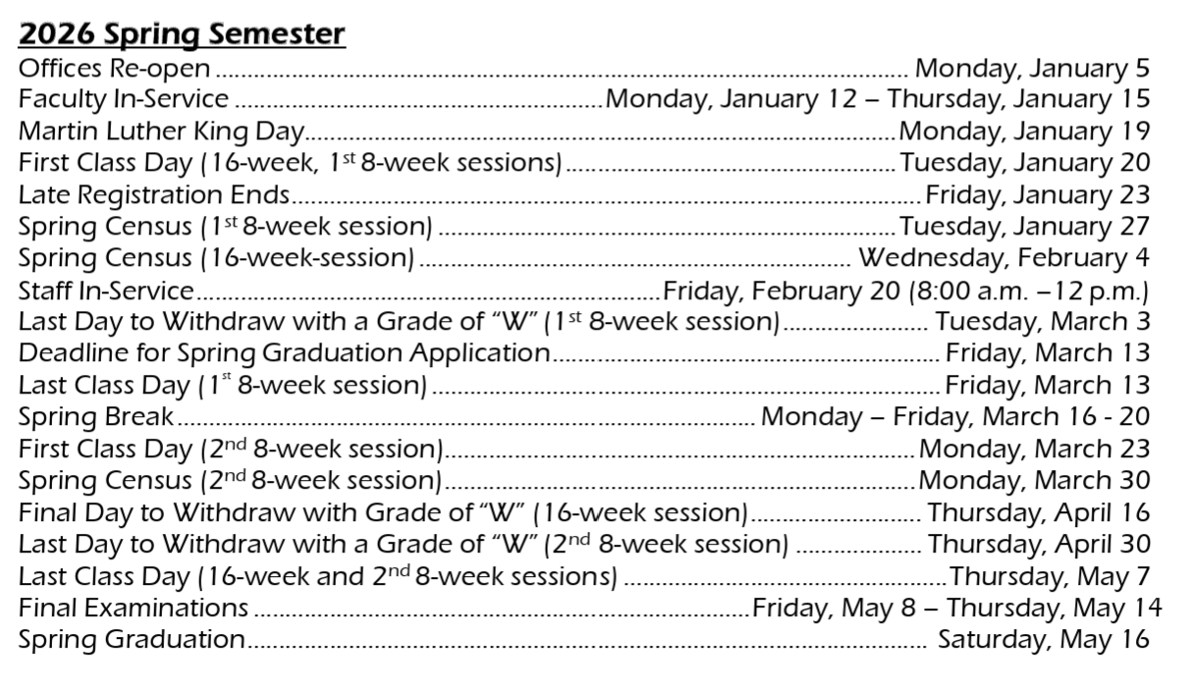

Course Identifier Codes
  DC | Dual Credit
  FE | Flex Entry Schedule
  HN | Honors
  HY | Hybrid
  IN | Independent Study
  MY | Mathways
  ST | Stacked
  TR | Traditional Schedule
  TV | Two-Way Video
  VC | Virtual College of Texas

