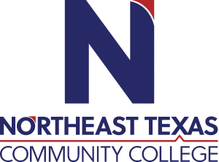 | NAME Dia Dodson Hardeman, D.C.  Office: MS building (Laboratories)  Phone: 903-918-8871  Email: dhardeman@ntcc.edu
 | “Northeast Texas Community College exists to provide personal, dynamic learning experiences empowering students to succeed.”

Education:

Institution | Major/Areas | Degree | Year(s)
Northeast Texas Community College | Math/Science | Associate of Science | 1997-1999
Parker Chiropractic College | Anatomy | Bachelor of Science | 1999-2001
Parker Chiropractic College | Chiropractic | Doctor of Chiropractic | 1999-2003

Teaching Experience:
Institution | Year(s)
Northeast Texas Community College | 2004-Present

Courses Taught at NTCC (last 3 years):
BIOL2401 Anatomy & Physiology I Online
BIOL2001 Anatomy & Physiology I Laboratory Online

Significant Professional Publications/Presentations (last 3 years):

